

**INSTITUTE FOR ADVANCED COMPUTING AND SOFTWARE DEVELOPMENT (IACSD) AKURDI, PUNE**

Documentation On

Talent on Tap

On Demand Home Service Web Application

PG-DAC March 2023

**Submitted By:**

**Group No: 56**

**Roll No. Name:**

**233127 Akshay Yelekar**

**233184 Pranav Dodmise**

**Mrs. Geeta Durante Mr. Rohit Puranik**

**Project Guide Centre co-ordinator**

# ABSTRACT

Our project Talent on Tap includes registration of users and professionals, storing their details into the system, and also booking their appointments for professionals.

Our application has the facility to give a unique id for every User and professional and stores the details of every user and professional automatically. A registered user can make appointments. The web application can be entered using email and password. It is accessible either by an administrator or registered Users. All the given data will be stored into the database, that data can be retrieved easily. The interface is very user-friendly. The data are well protected for personal use and makes the data processing very fast.

It has mainly three modules. One is at Administration Level and one is of User and one is Professional i.e. of admin, user, professional. The Application maintains authentication in order to access the application. The user can view professionals and book their services and schedule appointments via our application. Admin can approve professionals to be added.

# ACKNOWLEDGEMENT

Apart from the efforts of the team, the success of any project depends largely on the encouragement and guidelines of many others. We take this opportunity to express our gratitude to the people who have been instrumental in the successful completion of this project.

The completion of any inter-disciplinary project depends upon cooperation, coordination and combined efforts of several sources of knowledge.

We are eternally grateful to our guide Mrs.Geeta Darunte for her even willingness to give us valuable advice and direction under which we executed this project. Her constant guidance and willingness to share her vast knowledge made us understand this project and its manifestations in great depths and helped us to complete the assigned tasks. . I extend my sincere thanks to our respected Centre Co-ordinator Mr.Rohit Puranik for allowing us to use the facilities available. I would like to thank the other faculty members also, at this occasion. Last but not the least, I would like to thank my friends and family for the support and encouragement they have given me during the course of our work.

**Akshay Yelekar (233127)**

**Pranav Dodmise (233184)**

**Table of Contents**

ABSTRACT…………………………………………………………………………………….. 1

ACKNOWLEDGEMENT……………………………………………………………………. 2

INTRODUCTION…………………………………………………………………………….. 5

* 1. PROJECT OBJECTIVE…………………………………………………………………... 6
  2. PROJECT OVERVIEW…………………………………………………………………... 6
  3. PROJECT SCOPE…………………………………………………………………............ 6
  4. STUDY OF THE SYSTEM……………………………………………………………….. 7
     1. MODULES: …………………………………………………………………............. 7

SYSTEM ANALYSIS………………………………………………………………………….. 13

* 1. EXISTING SYSTEM……………………………………………………………………… 13
  2. PROPOSED SYSTEM…………………………………………………………………….. 13
  3. SYSTEM REQUIREMENT SPECIFICATION…………………………………………. 14
     1. GENERAL DESCRIPTION………………………………………………………... 14
     2. SYSTEM OBJECTIVES…………………………………………………………… 16
     3. SYSTEM REQUIREMENTS……………………………………………………… 16

SYSTEM DESIGN…………………………………………………………………................... 19

* 1. INPUT AND OUTPUT DESIGN…………………………………………………………. 19
     1. INPUT DESIGN: ………………………………………………………………….... 19
     2. OUTPUT DESIGN: ………………………………………………………………… 20

DATABASE DESIGN…………………………………………………………………............. 20

* 1. DATABASE…………………………………………………………………........................ 20
  2. SYSTEM TOOLS………………………………………………………………….............. 20
     1. FRONT END: …………………………………………………………………......... 20
     2. BACKEND: …………………………………………………………………............. 21

TABLE STRUCTURE: ………………………………………………………………….......... 28

FUTURE SCOPE…………………………………………………………………..................... 42

CONCLUSION…………………………………………………………………........................ 43

REFERENCES…………………………………………………………………......................... 44

**LIST OF FIGURES**

**FIGURE 1: ADMIN ACTIVITY DIAGRAM 08**

**FIGURE 2: CUSTOMER ACTIVITY DIAGRAM 10**

**FIGURE 3: PROFESSIONAL ACTIVITY DIAGRAM 12**

**FIGURE 4: DFD DIAGRAM 22**

**FIGURE 5: E-R DIAGRAM 23**

**FIGURE 6: CLASS DIAGRAM 24**

**FIGURE 7: USE CASE DIAGRAM……………………………………………………… 25**

**FIGURE 8: TABLE STRUCTURE 28**

**FIGURE 9: PROJECT DIAGRAMS 31**

# INTRODUCTION

The project Talent on Tap is an on demand home service application which includes registration of users and professionals, storing their details into the system. The software has the facility to give id for every user, professional and stores the details of every user and professional. Admin can approve professionals to be added as well as remove any professionals.

Talent on Tap web application can be entered using a user id and password. It is accessible either by administrators or users and professionals. Only they can add data into the database. The data can be retrieved easily. The interface is very user-friendly. The data is well protected for personal use and makes the data processing very fast. The Talent on Tap is an on demand home service which is powerful, flexible, and easy to use and is designed and developed to deliver real conceivable benefits to users.

This web application is designed for management purposes for users, to hire a wide range of professionals.

It is a software product suite designed to improve the quality and management of on demand home service. This web application enables you to develop your organization and improve its effectiveness and quality of work. Managing the key processes efficiently is critical to the success of user services and helps you manage your processes.

* 1. **PROJECT OBJECTIVE**
     1. Enhanced Service Accessibility
     2. Effortless Booking Process
     3. Quality Assurance through Reviews
     4. Efficient Appointment Management

These are the various jobs that need to be done in Talent on Tap web application.

* 1. **PROJECT OVERVIEW**

The On-Demand Home Service Web Application is a comprehensive and intuitive digital platform that seamlessly connects customers in need of various home services with skilled professionals who offer them. This innovative application is designed to enhance convenience, transparency, and efficiency for both customers and service providers, creating a user-centric environment that simplifies service discovery, booking, and management.

* 1. **PROJECT SCOPE**

Talent on Tap will be always available for users where they can access the functionalities provided by the web application. The system provides secure registration and profile management facilities for users and professionals.

It will have adequate searching mechanisms to get information about services offered by various professionals. The application also provides an easy solution for the registered seekers to request a specific type of service online using the internet and also allow users to book the schedule online for the services by professionals.

* 1. **STUDY OF THE SYSTEM**

## MODULES:

The application after careful analysis has been identified to be presented with the following modules and roles. The modules involved are:

* + - * Administrator
      * Users
      * Professional
      1. **Administrator:**

DESCRIPTION - The admin can add professionals, update professionals status, create/update/delete professionals.

MAIN FLOW OF EVENTS

* + - * 1. Admin logs in the system.
        2. Admin can add professionals.
        3. Admin maintains professional’s record.
        4. Admin View the blood services available and also can manage them.
        5. Admin can add professionals and manage and see them in a list form.
        6. List of registered professional’s details is displayed.

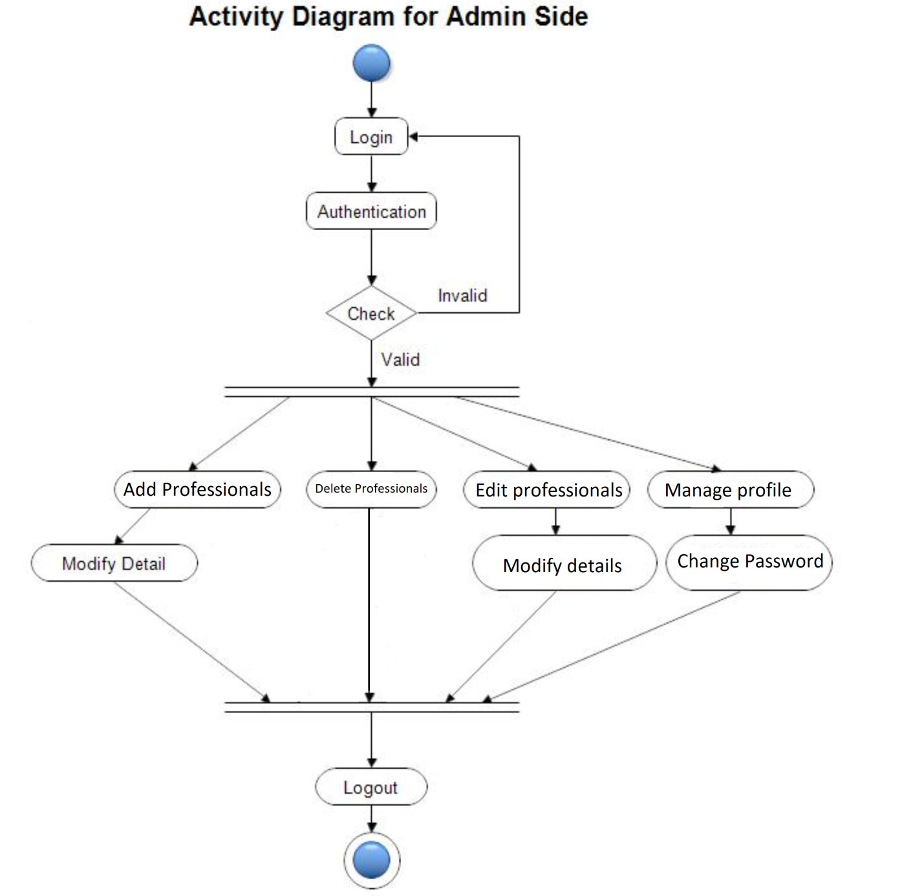

*Figure 1 Admin Activity Diagram*

* + - * **Add professionals**

Admin can add new professionals and register him with details like name, Email, age, gender, Id card and its number etc.

* + - * **Edit professional**s

Admin will have a list view of all the existing professionals. He can also edit for a particular professional.

* + - * **Add/Remove professional**s

Admin can add /remove professional.

* + - * **View professional**s

Admin will have a dashboard where he/she can view all the professionals.

* + - 1. **Users:**

MAIN FLOW OF EVENTS

* + - * 1. Users can sign up in the system.
        2. Users can sign up by filling their details like name, Email, age, mobile number , etc.
        3. Users can sign in to the application and manage their profile.
        4. Users can view a list of all appointments.
        5. Users can update and cancel their appointments (bookings).

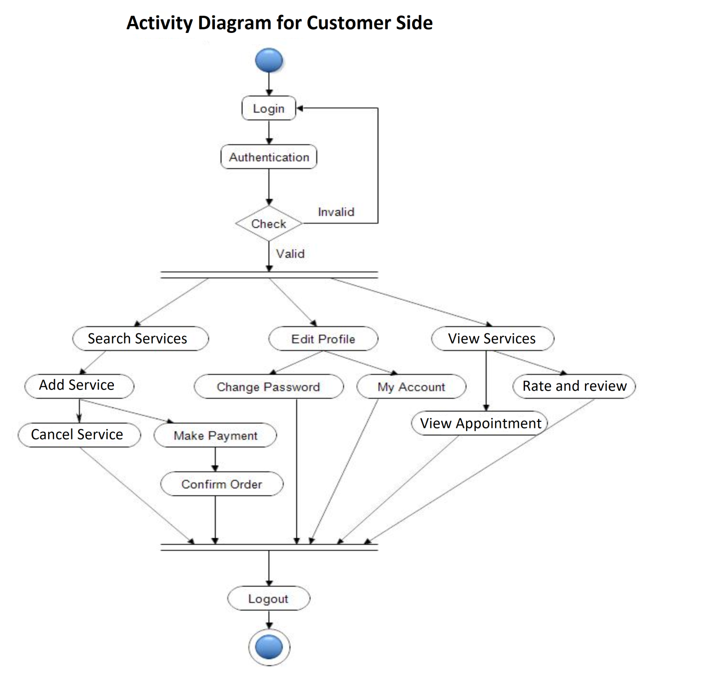

*Figure 2 Customer’s Activity Diagram*

* + - * **Create Account**

Users can create an account by filing proper details.

* + - * **List All Appointments**

Users will have a list view of all the appointments of him/her.

* + - * **Manage Profile**

Users can manage their profile and can update their details.

* + - * **Book Appointments**

Users can book an appointment with the professional according to their preference.

* + - 1. **Professionals:**

MAIN FLOW OF EVENTS

1. Professionals can register with correct details.
2. Professionals can sign in by using their email and password.
3. Professionals can edit their profiles.
4. Professionals can manage their bookings and appointments.
   * + - **Create Account**

Professionals can create an account by filing proper details.

* + - * **Manage Profile**

Professionals can manage their profile and can update their details.

* + - * **List All Appointments**

Professionals will have a list view of all the appointments of him/her.

* + - * **Manage Appointments**

Professionals can manage appointments with the users according to their preference.

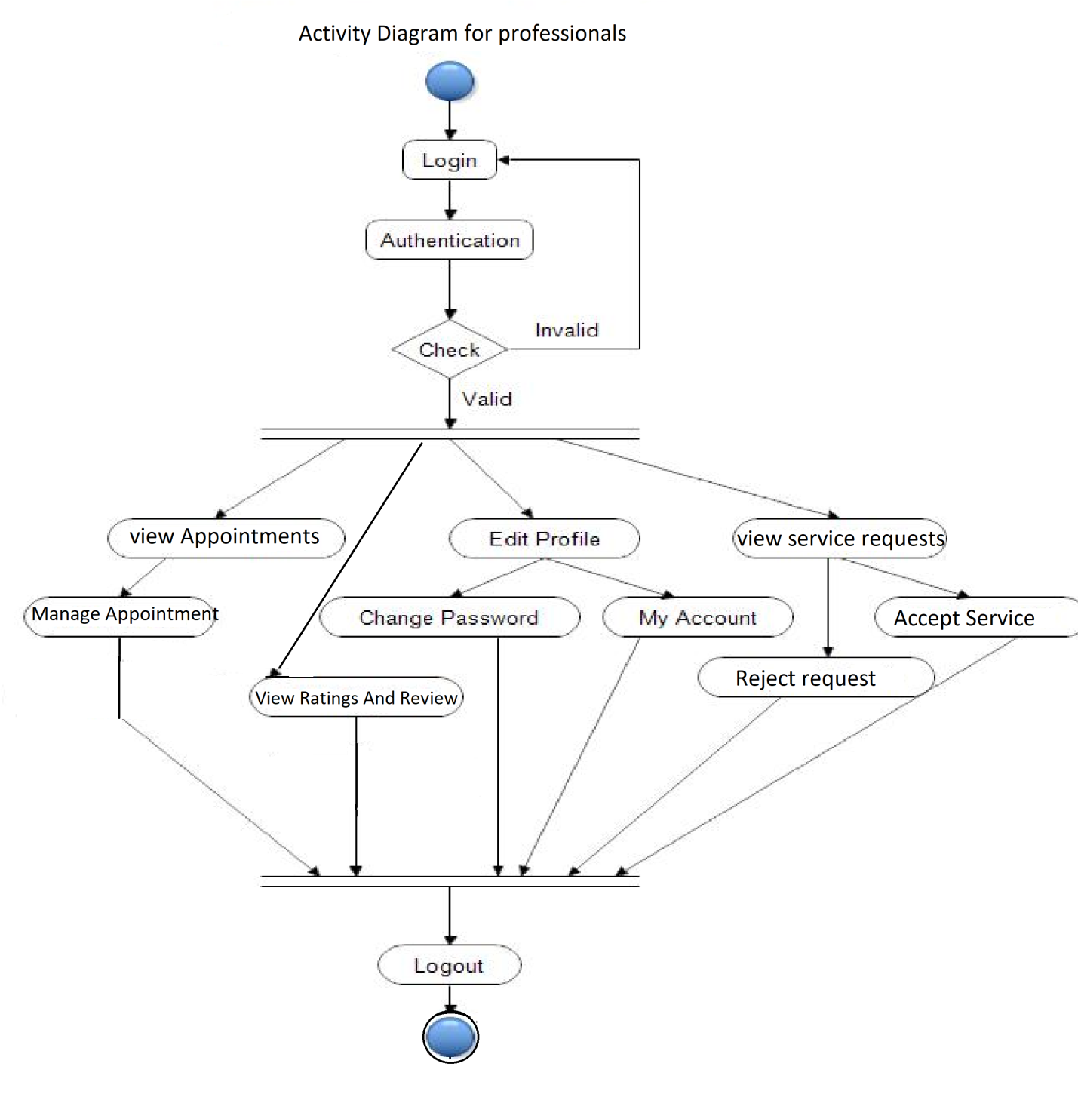

# SYSTEM ANALYSIS

System analysis is the process of gathering and interpreting facts, diagnosing problems, and using information to recommend improvements on the system. System analysis is a problem solving activity that requires intensive communication between the system users and system developers.

System analysis or study is an important phase of any system development process. The system is viewed as a whole, the inputs are identified, and the system is subjected to close study to identify the problem areas. The solutions are given as a proposal. The proposal is reviewed on user request and suitable changes are made. This loop ends as soon as the user is satisfied with the proposal.

* 1. **EXISTING SYSTEM**

In the existing system on demand home service functionalities are handled manually by admin by keeping the records of every professional in a register. There is no record present for billings of users and no history is available for appointments.

* It is less user-friendly.
* It is difficult to know the user’s history.
* Difficult to maintain a user record.
  1. **PROPOSED SYSTEM**

In the proposed system, we are developing a web application for on demand home service. In which three modules have access to the system. The proposed system allows to keep the record for every user and professional. It will also have all the records of users and professionals booking and appointment.

* 1. **SYSTEM REQUIREMENT SPECIFICATION**
     1. **GENERAL DESCRIPTION Product Description:**

Talent on Tap is an online website, an outstanding way of bringing

Users and professionals on an online platform to provide services at home in an efficient manner. This website provides an interactive interface through which a user can interact with different areas of the application easily by maintaining appointments as well as user’s information. It includes smooth functionality and efficiency that get the user’s work done. Talent on Tap keeps the information about the professional and user data updated.

**Problem Statement:**

* Inefficient Service Booking Process:

Many customers face challenges when seeking home services due to the lack of a streamlined and user-friendly platform. Traditional methods of finding and booking services can be time-consuming and frustrating. There is a need for a solution that simplifies the process, allowing customers to quickly find and schedule services based on their preferences.

* Lack of Reliable Service Professionals:

Locating trustworthy and skilled professionals for home services can be a daunting task. Customers often struggle to find professionals who offer quality services, leading to concerns about safety and service quality. Addressing this issue requires a platform that connects customers with certified and reliable professionals while also offering a way for professionals to showcase their skills.

* Communication Gaps Between Customers and Professionals:

Existing communication channels between customers and professionals are often fragmented and inefficient. Miscommunication regarding appointment details, availability, and service requirements can lead to delays and misunderstandings. There is a need for a platform that enables seamless communication, ensuring both parties are on the same page.

* Absence of Transparent Feedback Mechanisms:

Customers lack an effective means to provide feedback and share their experiences with professionals after service completion. This lack of transparency can hinder accountability and hinder the improvement of service quality. A solution is required that empowers customers to provide reviews and ratings, contributing to a transparent and accountable service ecosystem.

* Complexity in Managing Appointments:

Professionals offering home services often struggle with managing their appointments efficiently. Balancing their availability, accepting bookings, and organizing schedules manually can lead to errors and overlaps. The application needs to address this challenge by offering professionals a platform to manage their appointments effectively.

* Administrator Overhead and Professional Control:

Administrators overseeing service platforms face difficulties in managing professional activities, services, and maintaining service quality. An efficient administrator control panel is necessary to ensure that administrators can monitor, moderate, and maintain the platform without cumbersome manual intervention.

**SYSTEM OBJECTIVES**

* To provide a Web application for on demand home service
* To provide a web app for users to book and avail services by various professionals.
* To provide a web app for professionals to showcase their services and manage bookings and appointments.
  + 1. **SYSTEM REQUIREMENTS**
       1. **NON-FUNCTIONAL REQUIREMENTS**

Following Non-Functional Requirements will be there in the insurance to the internet:

1. Performance:

- The application shall respond to user interactions within 2 seconds.

- The platform shall support a minimum of 500 simultaneous users.

2. Security:

- User passwords and sensitive data shall be securely encrypted.

- Secure authentication and authorization mechanisms shall be implemented.

- Payment transactions shall be processed securely using encryption.

3. Usability:

- The user interface shall be intuitive and user-friendly for customers and professionals.

- The application shall be accessible to users with disabilities, conforming to relevant accessibility standards.

4. Reliability:

- The platform shall have an uptime of at least 99.9%.

- Regular data backups shall be performed to ensure data integrity.

5. Compatibility:

- The application shall be compatible with major web browsers (Chrome, Firefox, Safari, Edge).

- The platform shall be responsive and usable on various devices, including mobile phones and tablets.

6. Documentation:

- User documentation shall be provided, including user guides and FAQs.

- Administrator documentation shall cover user management and platform maintenance.

7. Scalability

- The application architecture shall support scalability to accommodate a growing user base.

8. Privacy and Compliance

- The application shall adhere to relevant data protection and privacy regulations.

- Users' personal and payment information shall be kept private and secure.

9. Data Integrity:

- User-generated data (appointments, reviews) shall be stored securely and accurately.

10. Performance Monitoring:

- The application shall have monitoring tools to track system health and performance.

* + - 1. **FUNCTIONAL REQUIREMENTS**

1. User Management:

- Customers, professionals, and administrators can register and create accounts.

- Users can log in using their registered credentials.

- Users can update their profile information.

2. Service Listings:

- Professionals can create and manage service listings.

- Customers can browse and search for services.

- Service listings include service details, pricing, availability, and professional information.

3. Booking and Appointments:

- Customers can request service appointments.

- Professionals can view and manage appointment requests.

- Users can view upcoming and past appointments.

4. Communication:

- Users can communicate through real-time messaging.

- Professionals and customers receive notifications for new messages and updates.

5. Reviews and Ratings:

- Customers can leave reviews and ratings for services.

- Professionals can view reviews.

6. Calendar and Schedule Management:

- Users can view appointments and availability in a calendar view.

- Professionals can set their availability and manage appointments.

7. Administrator Tools:

- Administrators can manage services, and appointments.

- Administrators can resolve disputes and address platform issues.

# SYSTEM DESIGN

System design is the solution for the creation of a new system. This phase focuses on the detailed implementation of the feasible system. Its emphasis is on translating design specifications to performance specification. System design has two phases of development.

* Logical Design
* Physical Design

During logical design phase the analyst describes inputs (sources), outputs (destinations), databases (data sores) and procedures (data flows) all in a format that meets the user requirements. The analyst also specifies the needs of the user at a level that virtually determines the information flow in and out of the system and the data resources. Here the logical design is done through data flow diagrams and database design. The physical design is followed by physical design or coding. Physical design produces the working system by defining the design specifications, which specify exactly what the candidate system must do. The programmers write the necessary programs that accept input from the user, perform necessary processing on accepted data and produce the required report on a hard copy or display it on the screen.

* 1. **INPUT AND OUTPUT DESIGN**
     1. **INPUT DESIGN:**

Input design is the link that ties the information system into the world of its users. The input design involves determining the inputs, validating the data, minimizing the data entry and provides a multi-user facility. Inaccurate inputs are the most common cause of errors in data processing. Errors entered by the data entry operators can be controlled by input design. The user-originated inputs are converted to a computer-based format in the input design. Input data are collected and organized into groups of similar data. Once identified, the appropriate input media are selected for processing. All the input data are validated and if any data violates any conditions, the user is warned by a message. If the data satisfies all the conditions, it is transferred to the appropriate tables in the database. In this project the student details are to be entered at the time of registration. A page is designed for this purpose which is user friendly and easy to use. The design is done such that users get appropriate messages when exceptions occur.

* + 1. **OUTPUT DESIGN:**

Computer output is the most important and direct source of information to the user. Output design is a very important phase since the output needs to be in an efficient manner. Efficient and intelligible output design improves the system relationship with the user and helps in decision making. Allowing the user to view the sample screen is important because the user is the ultimate judge of the quality of output. The output module of this system is the selected notifications.

# DATABASE DESIGN

* 1. **DATABASE**

Databases are the storehouses of data used in the software systems. The data is stored in tables inside the database. Several tables are created for the manipulation of the data for the system. Two essential settings for a database are

* Primary key - the field that is unique for all the record occurrences
* Foreign key - the field used to set relation between tables Normalization is a technique to avoid redundancy in the tables.
  1. **SYSTEM TOOLS**

The various system tools that have been used in developing both the front end and the back end of the project are being discussed in this chapter.

* + 1. **FRONT END:**

React is a library which is developed by Face book is utilized to implement the frontend. React (also known as React.js or React JS) is a [free and open-source](https://en.wikipedia.org/wiki/Free_and_open-source_software) [front-end](https://en.wikipedia.org/wiki/Front_end_and_back_end) [JavaScript library](https://en.wikipedia.org/wiki/JavaScript_library) for building [user interfaces o](https://en.wikipedia.org/wiki/User_interfaces)r UI components. It is maintained by [Face](https://en.wikipedia.org/wiki/Facebook%2C_Inc) [book a](https://en.wikipedia.org/wiki/Facebook%2C_Inc)nd a community of individual developers and companies. React can be used as a base in the development of [single page o](https://en.wikipedia.org/wiki/Single-page_application)r mobile applications. However, React is only concerned with state management and rendering that state to the [DOM,](https://en.wikipedia.org/wiki/Document_Object_Model) so creating React applications usually requires the use of additional libraries for routing, as well as certain client-side functionality.

Version-React 18.2.0

* + 1. **BACKEND:**

**MySQL:**The back end is implemented using MySQL which is used to design databases.

MySQL is the world's second most widely used open-source relational database

management system (RDBMS). The SQL phrase stands for Structured Query Language.

Version- 8.1.0

**Spring-Boot:**

This is used to connect MYSQL and fetch data from database and store the data in database. The Spring Framework is a[n application framework a](https://en.wikipedia.org/wiki/Application_framework)nd [inversion of control](https://en.wikipedia.org/wiki/Inversion_of_control) [container f](https://en.wikipedia.org/wiki/Servlet_container)or the [Java platform. T](https://en.wikipedia.org/wiki/Java_platform)he framework's core features can be used by any Java application, but there are extensions for building web applications on top of the [Java EE](https://en.wikipedia.org/wiki/Java_EE) [(](https://en.wikipedia.org/wiki/Java_EE)Enterprise Edition) platform. Although the framework does not impose any specific [programming model,](https://en.wikipedia.org/wiki/Programming_model) it has become popular in the Java community as an addition to the [Enterprise JavaBeans (](https://en.wikipedia.org/wiki/Enterprise_JavaBeans)EJB) model. The Spring Framework is Open-source Framework.

Version- 2.7.15

**Data Flow Diagram (DFD):**

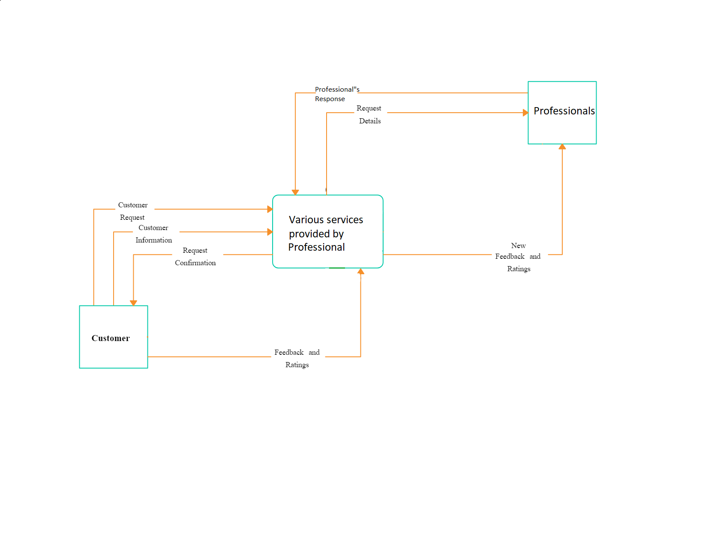

# E-R Diagram:

# 

**Class Diagram:**

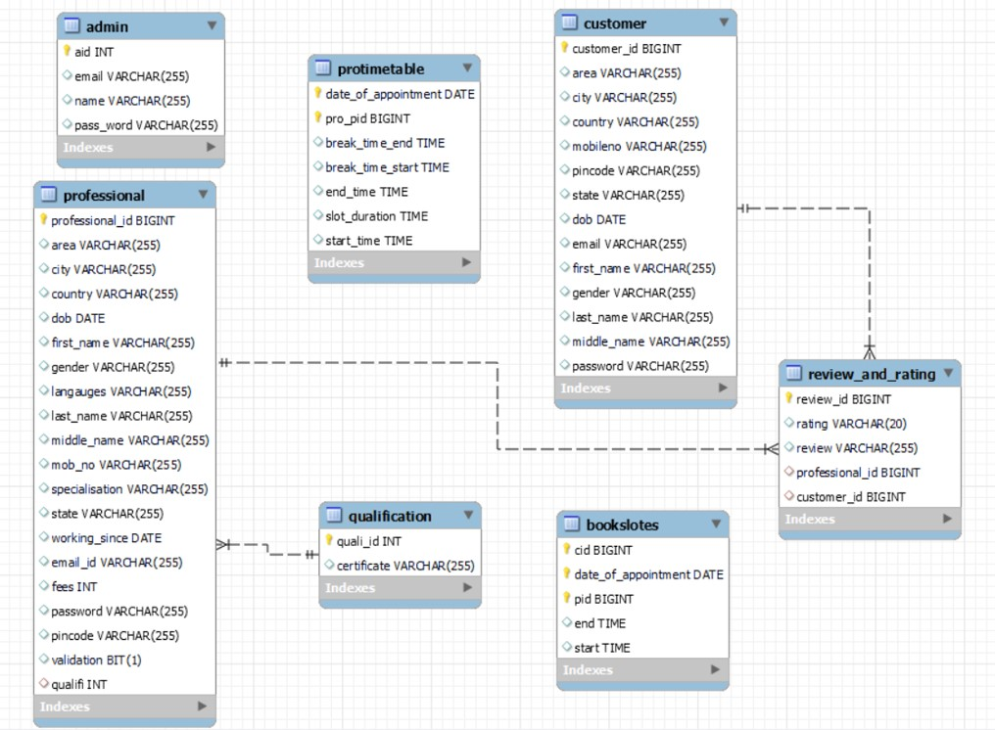

**Use Case Diagram :**

**Admin :**

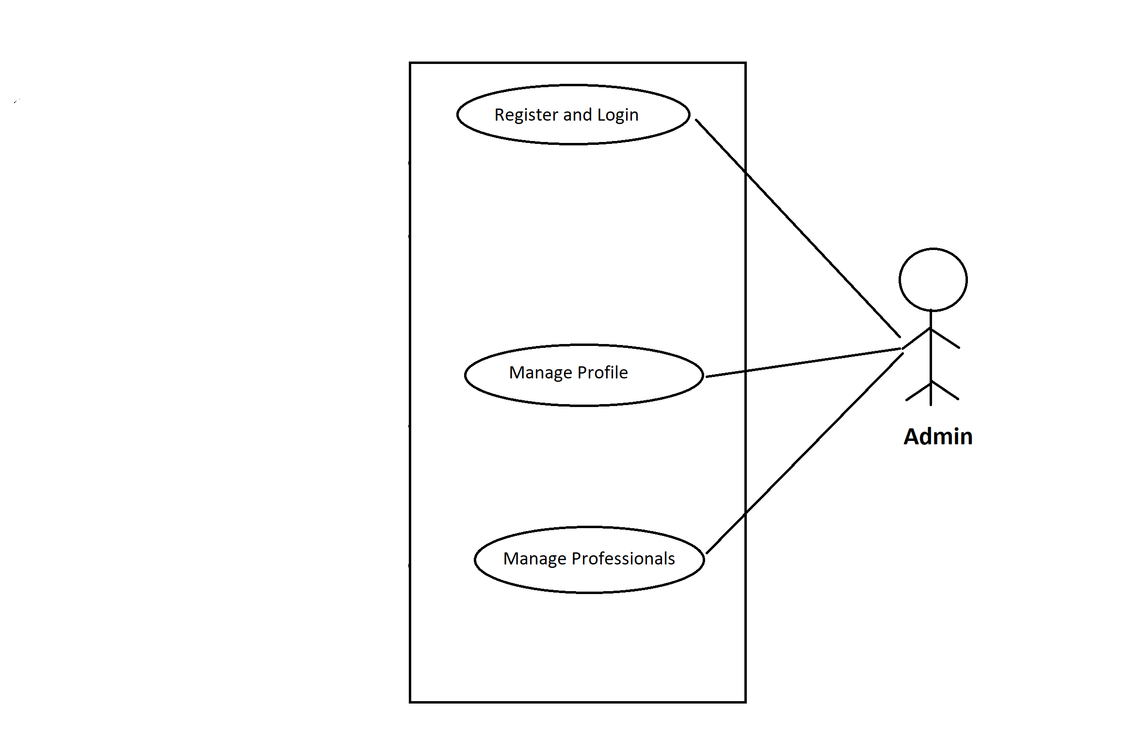

**Customer :** 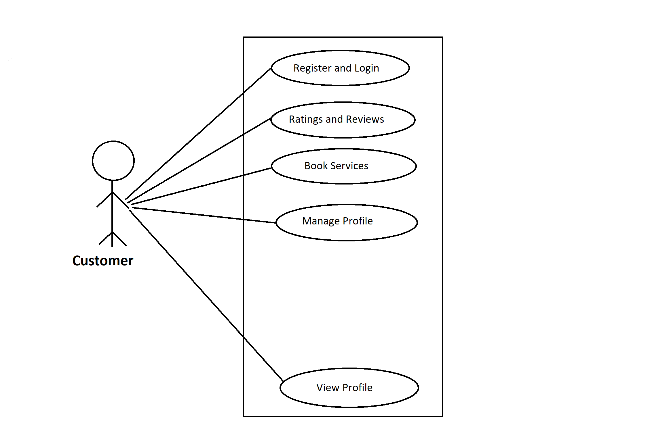

# 

# Professional :

# 

# TABLE STRUCTURE:

# Admin:

# 

**Customers:**

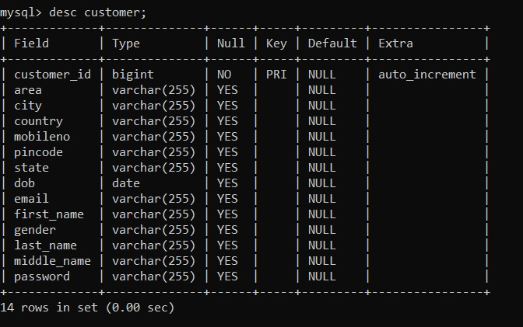

**Professionals:**

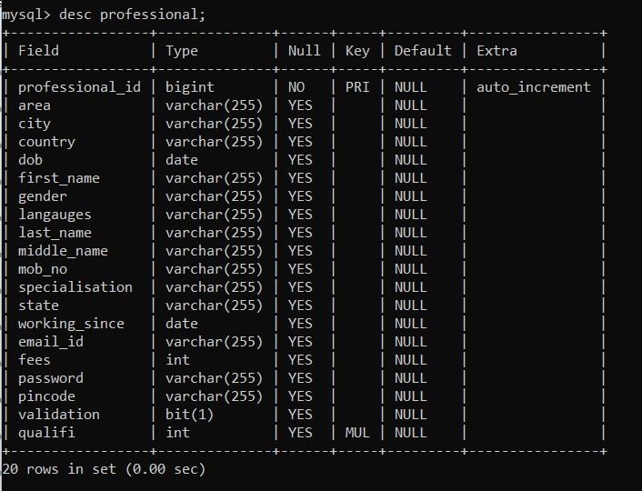

**Book slots:**

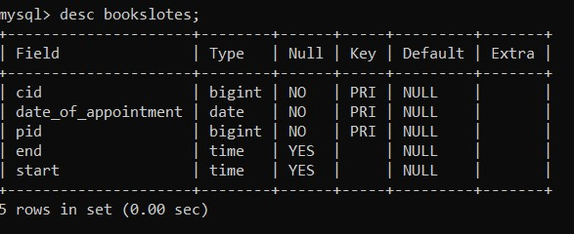

**Professional Timetable:**

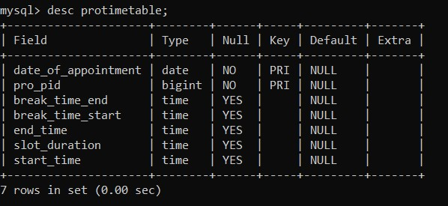

**Review and Rating :**

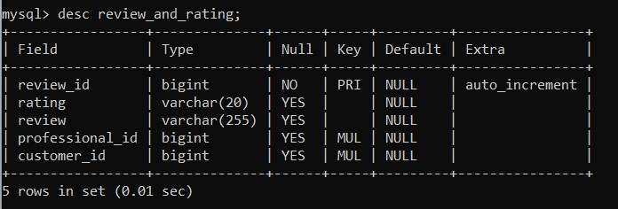

**Project Screenshots:**

**Home Page :**

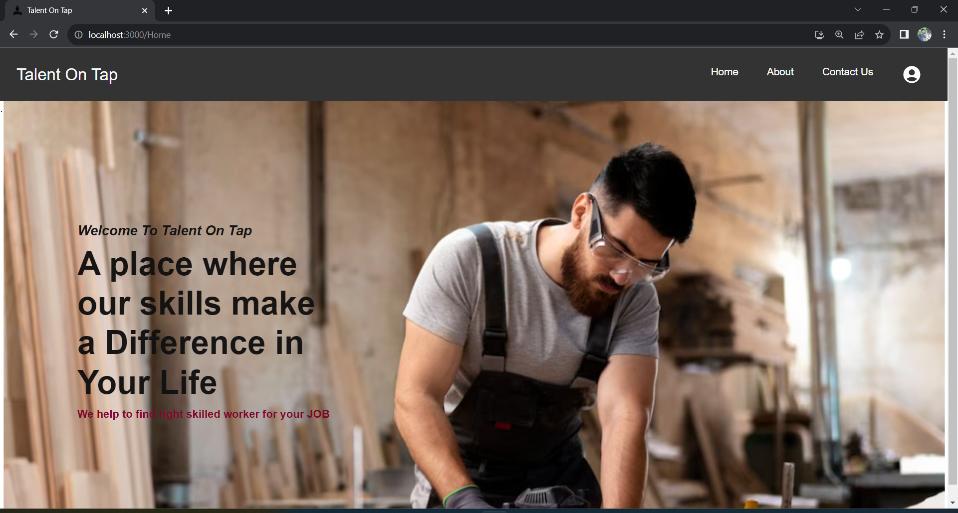

**About Us :**

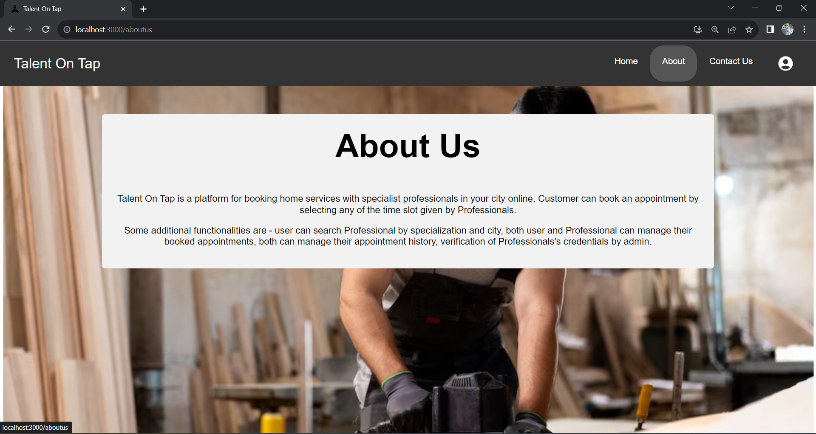

**Accounts :**

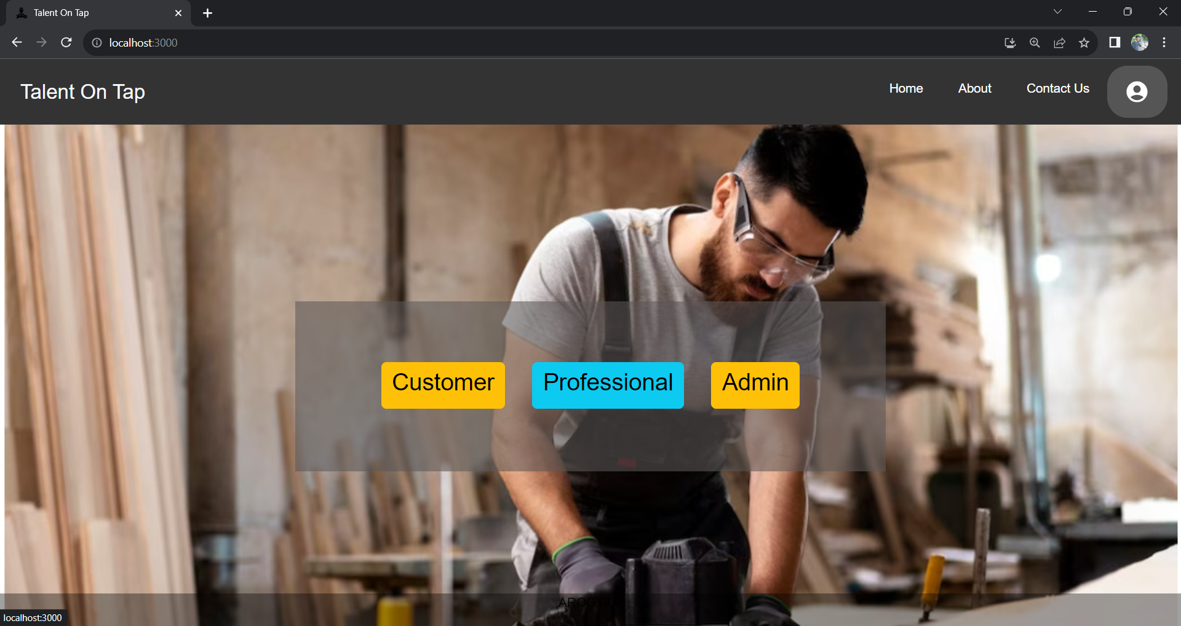

**Sign In :**

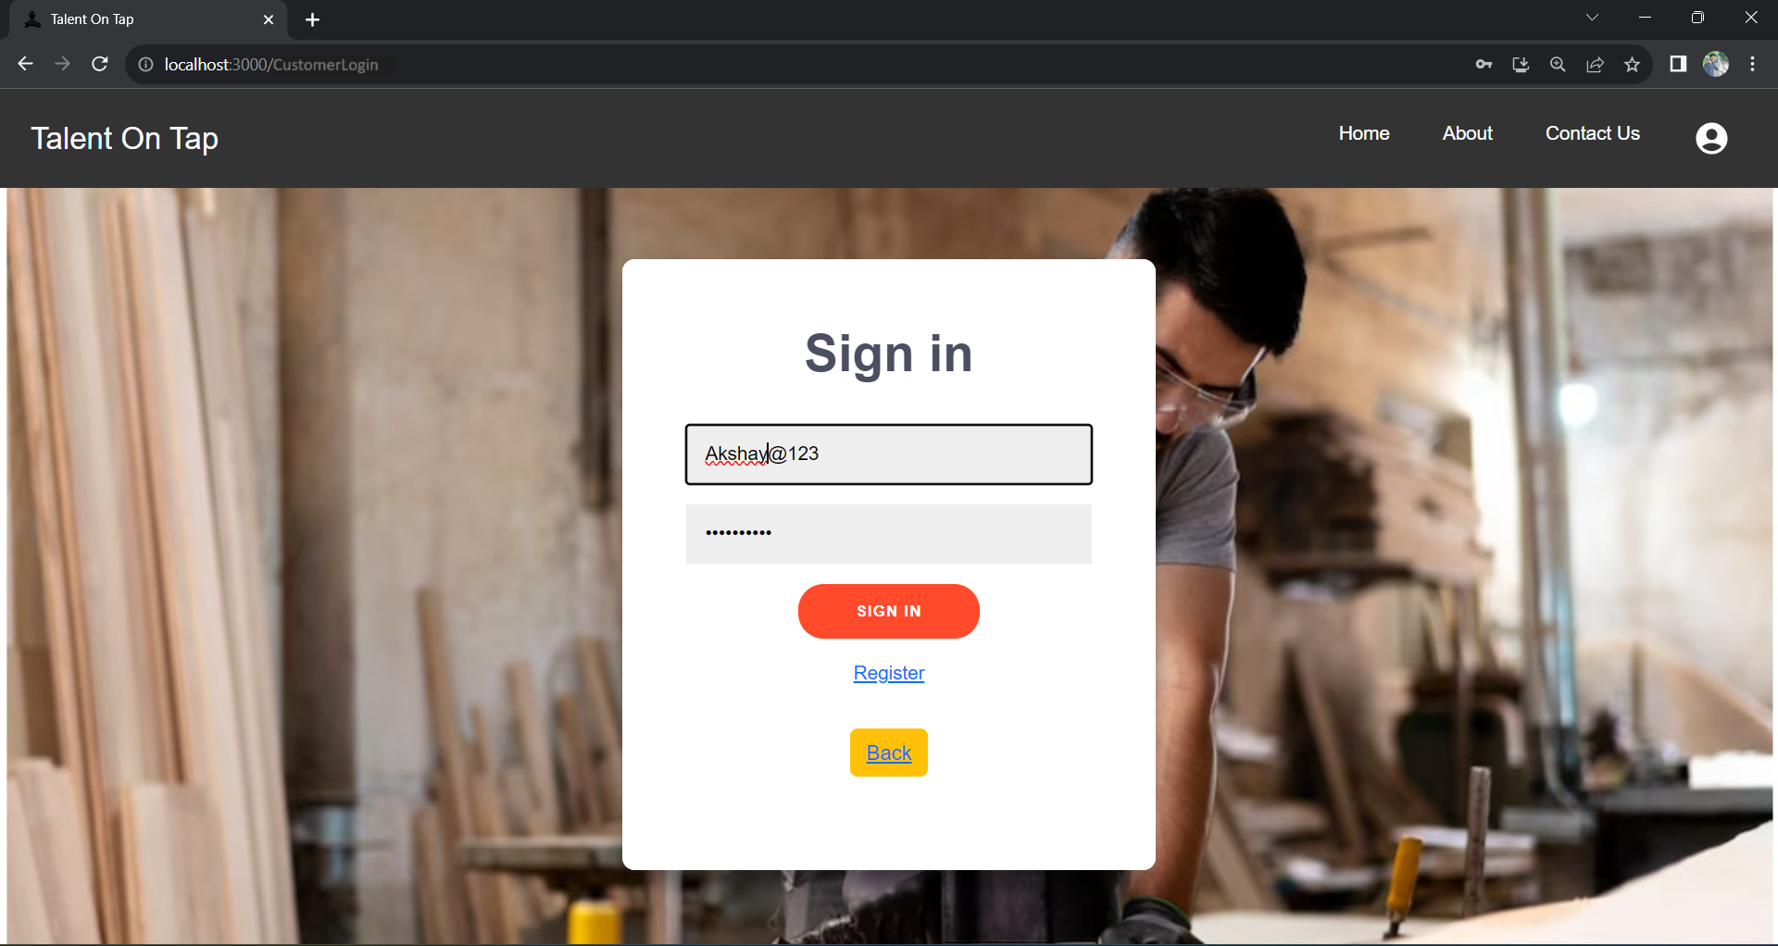

**Admin:**

**Admin Homepage :**

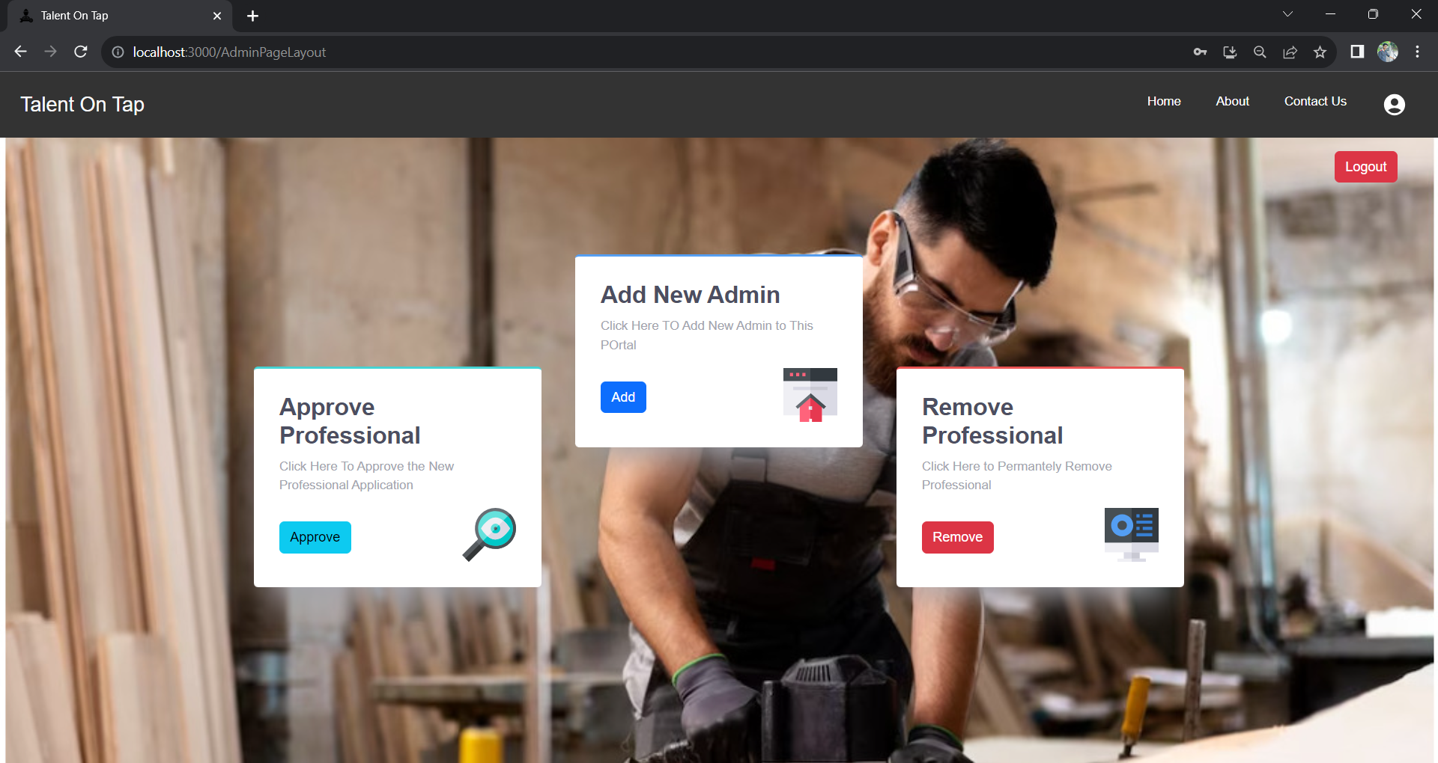

**Approve Professional :**

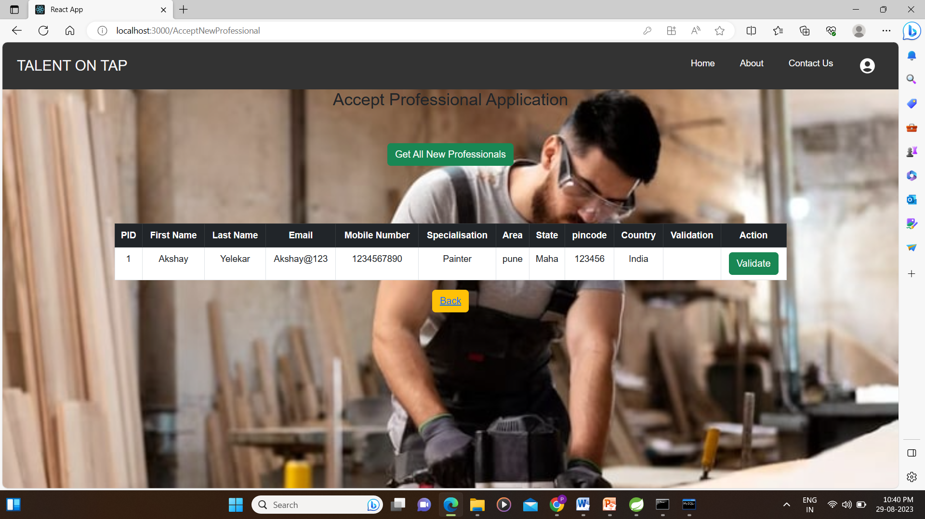

**Add Admin :**

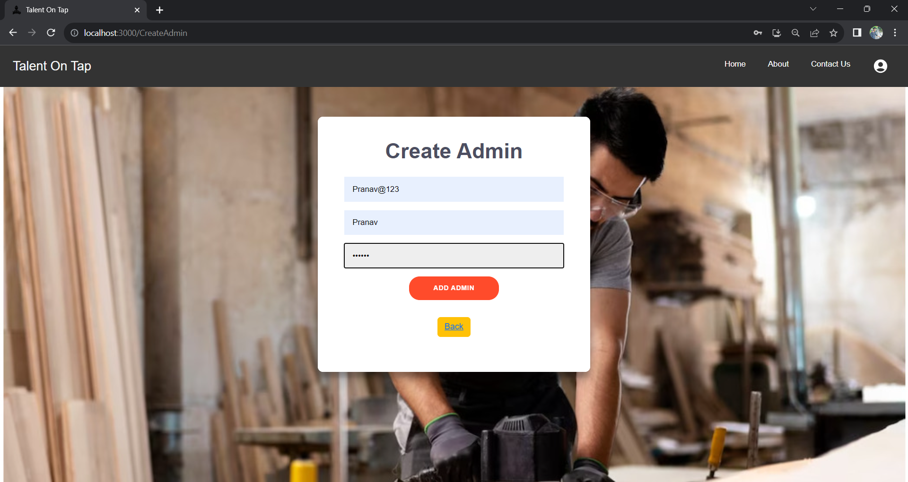

**Delete Professional :**

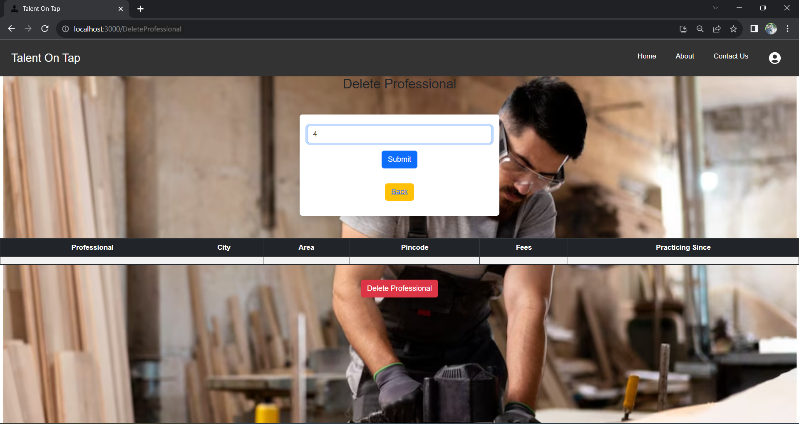

**Professionals:**

**Professionals Homepage :**

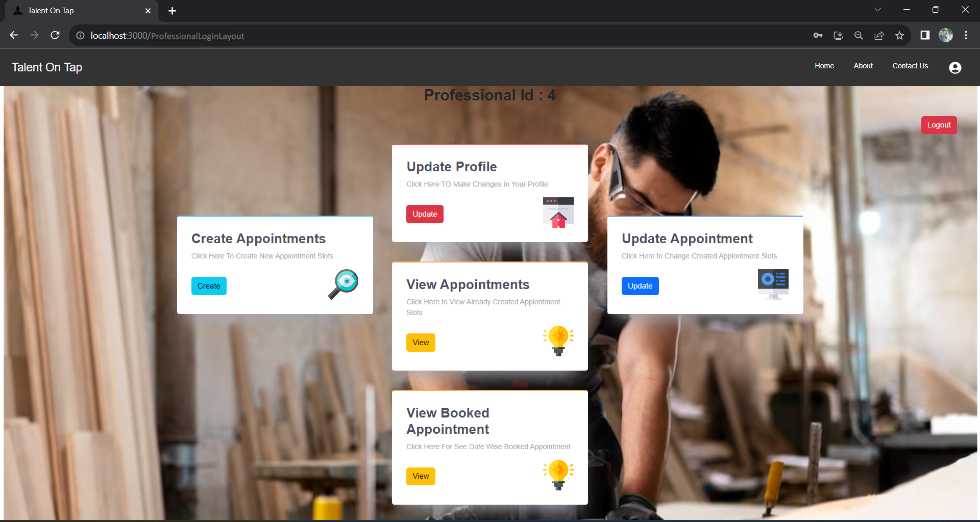

**Register Professional :**

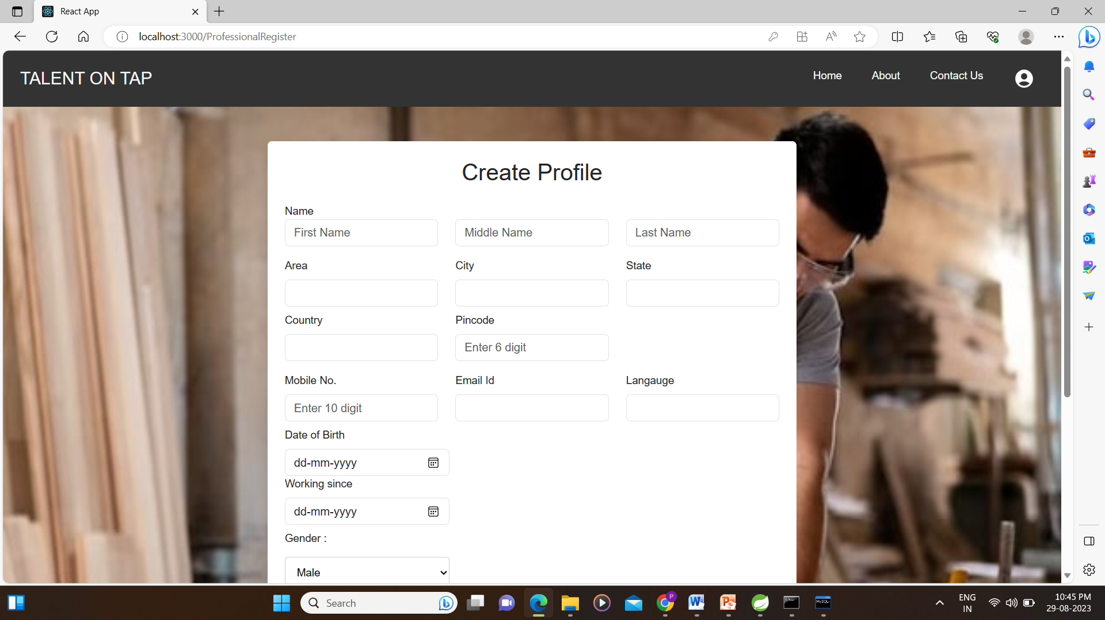

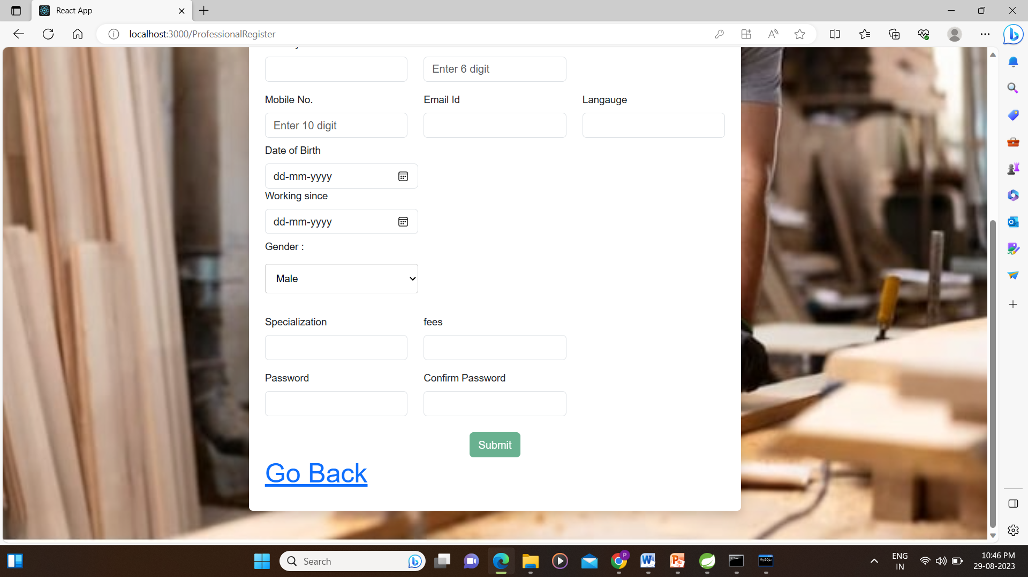

**Create Appointment :**

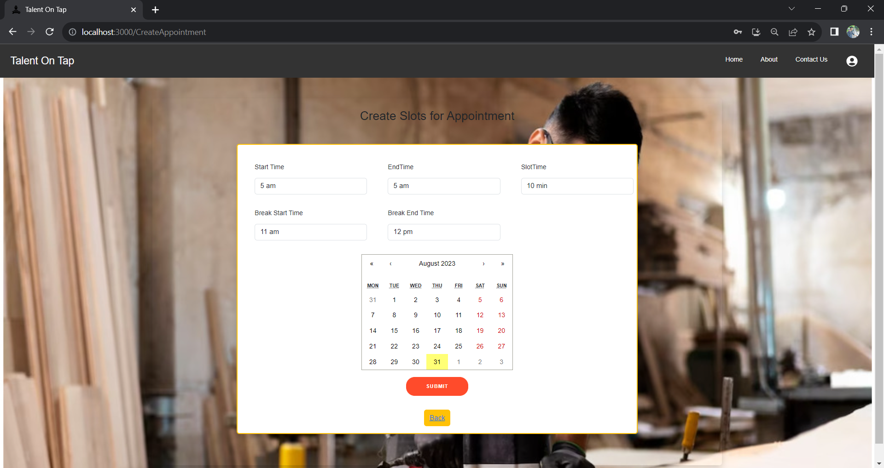

**View Appointment :**

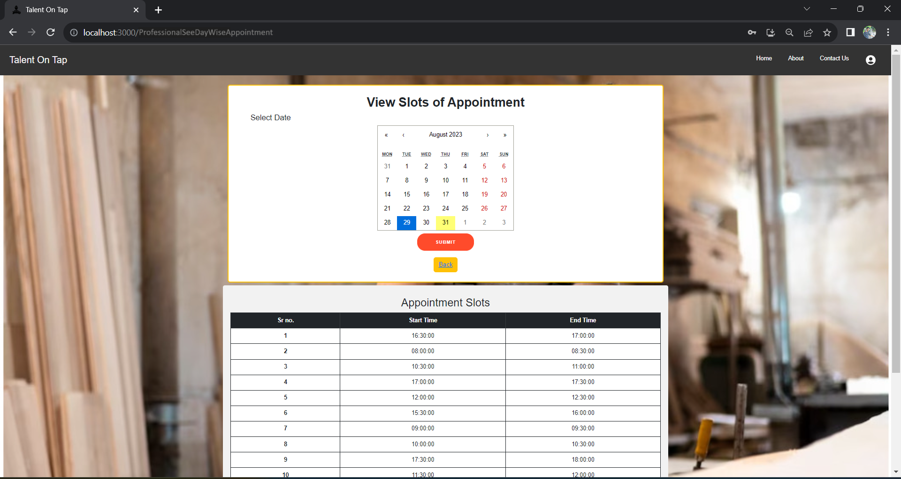

**Update Appointment :**

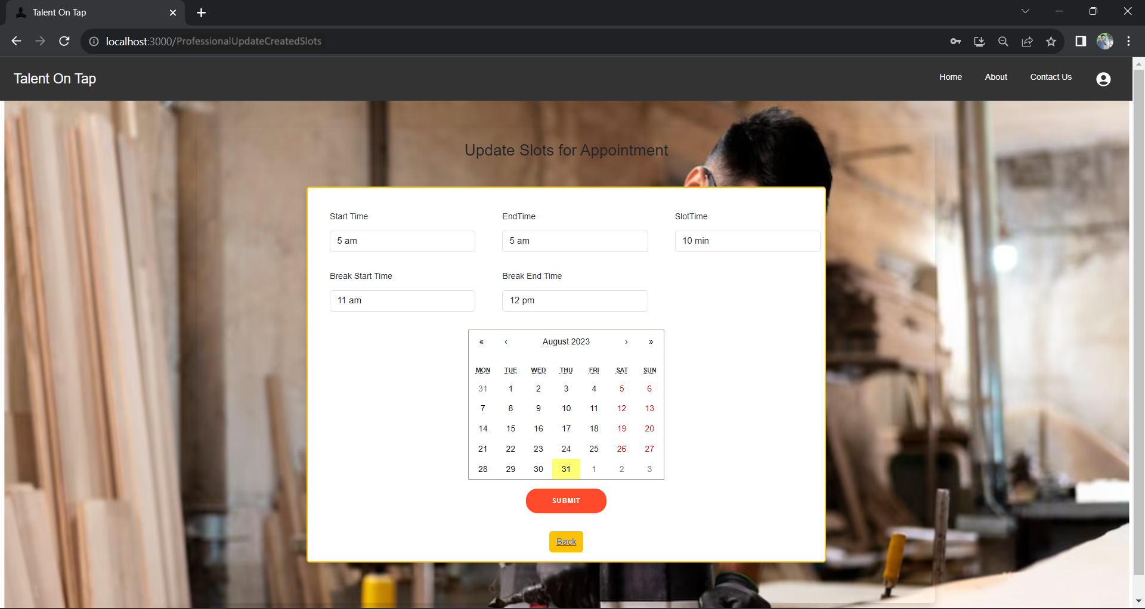

**View Booked Appointment :**

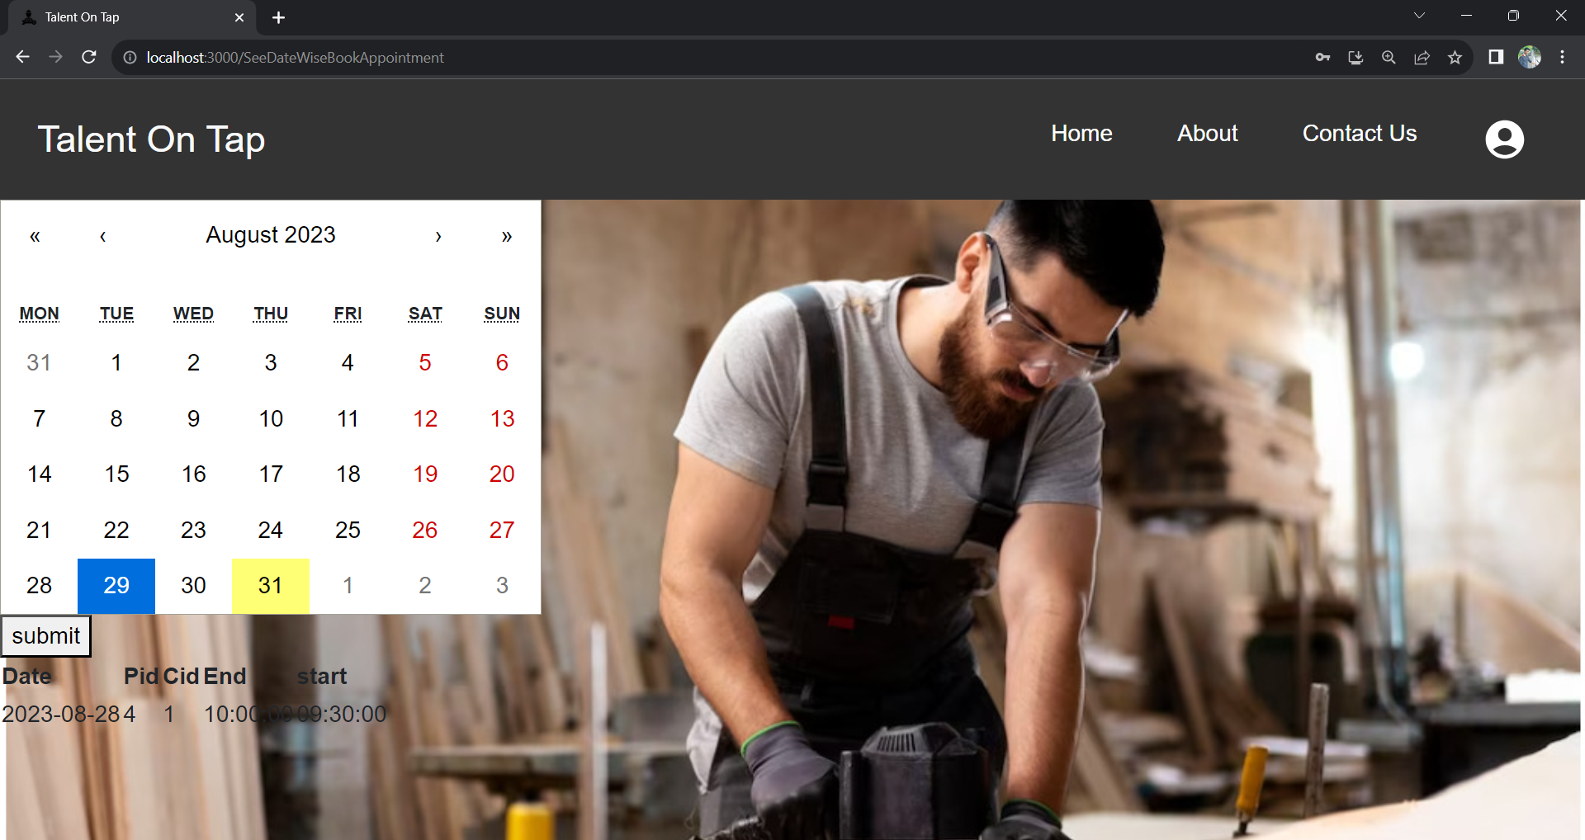

**Customer:**

**Customer Homepage :**

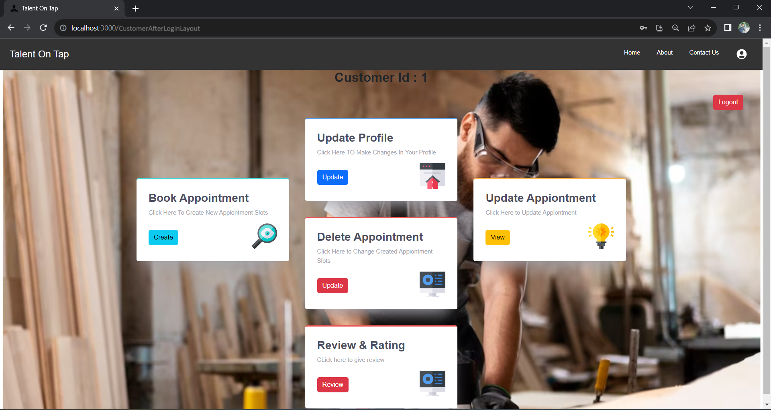

**Update Profile :**

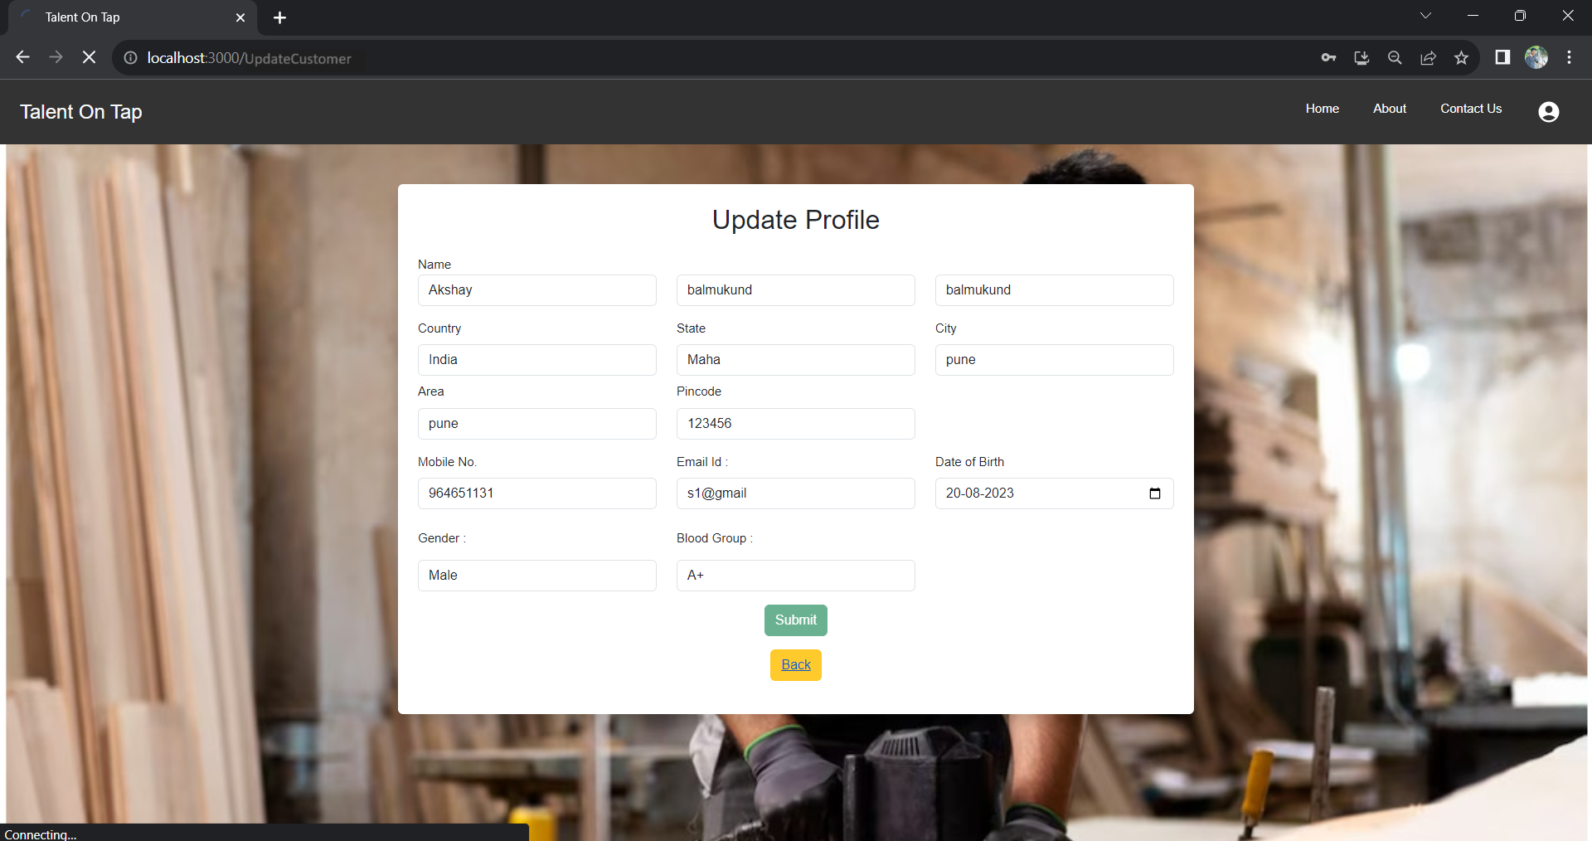

**Book Appointment :**

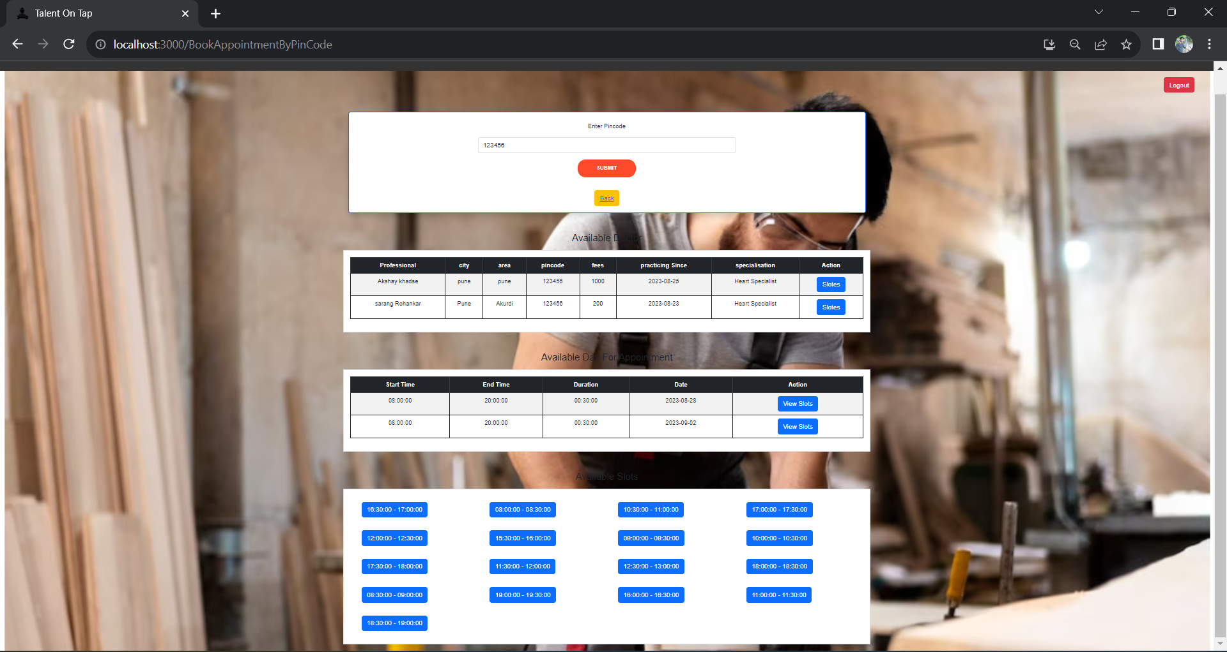

**Update Appointment :**

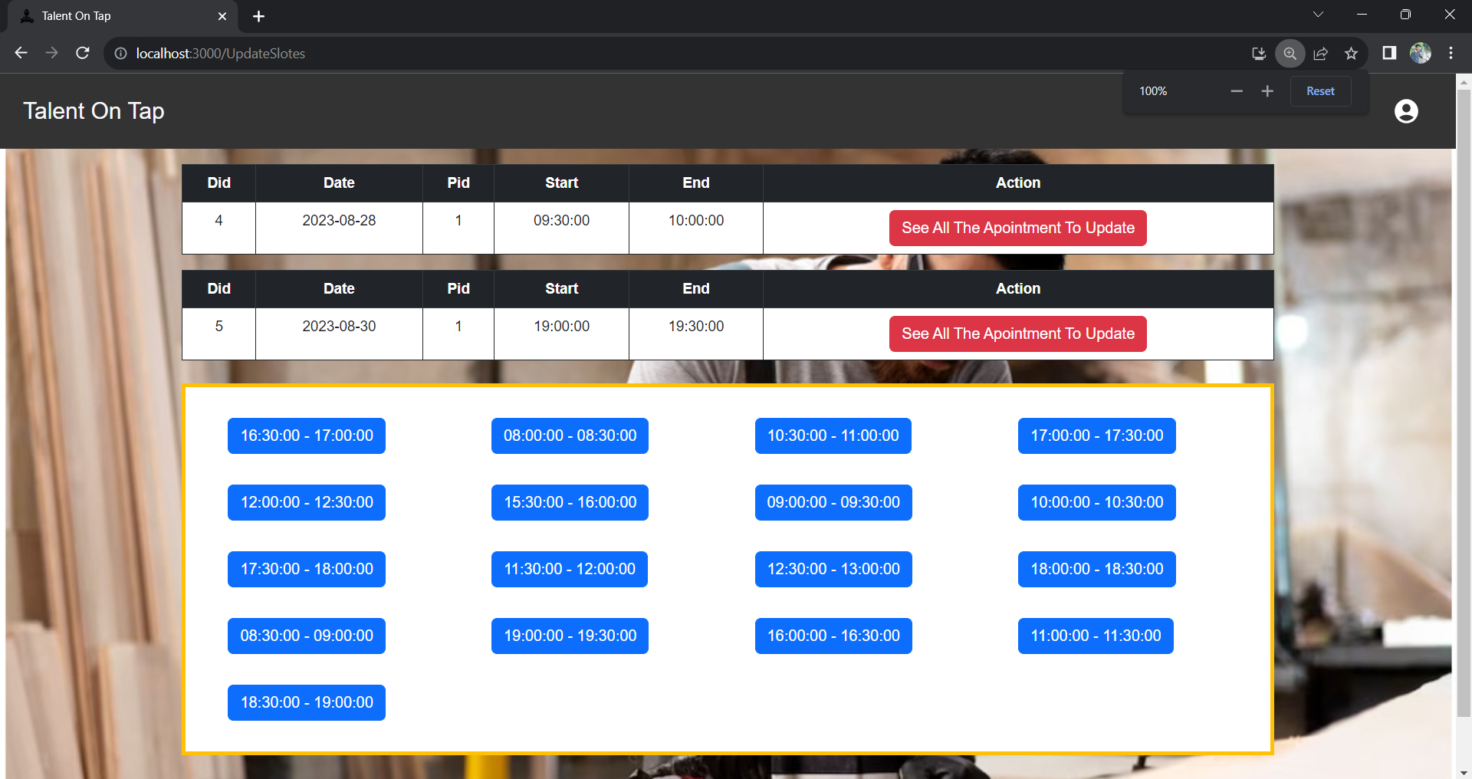

**Delete Appointment:**

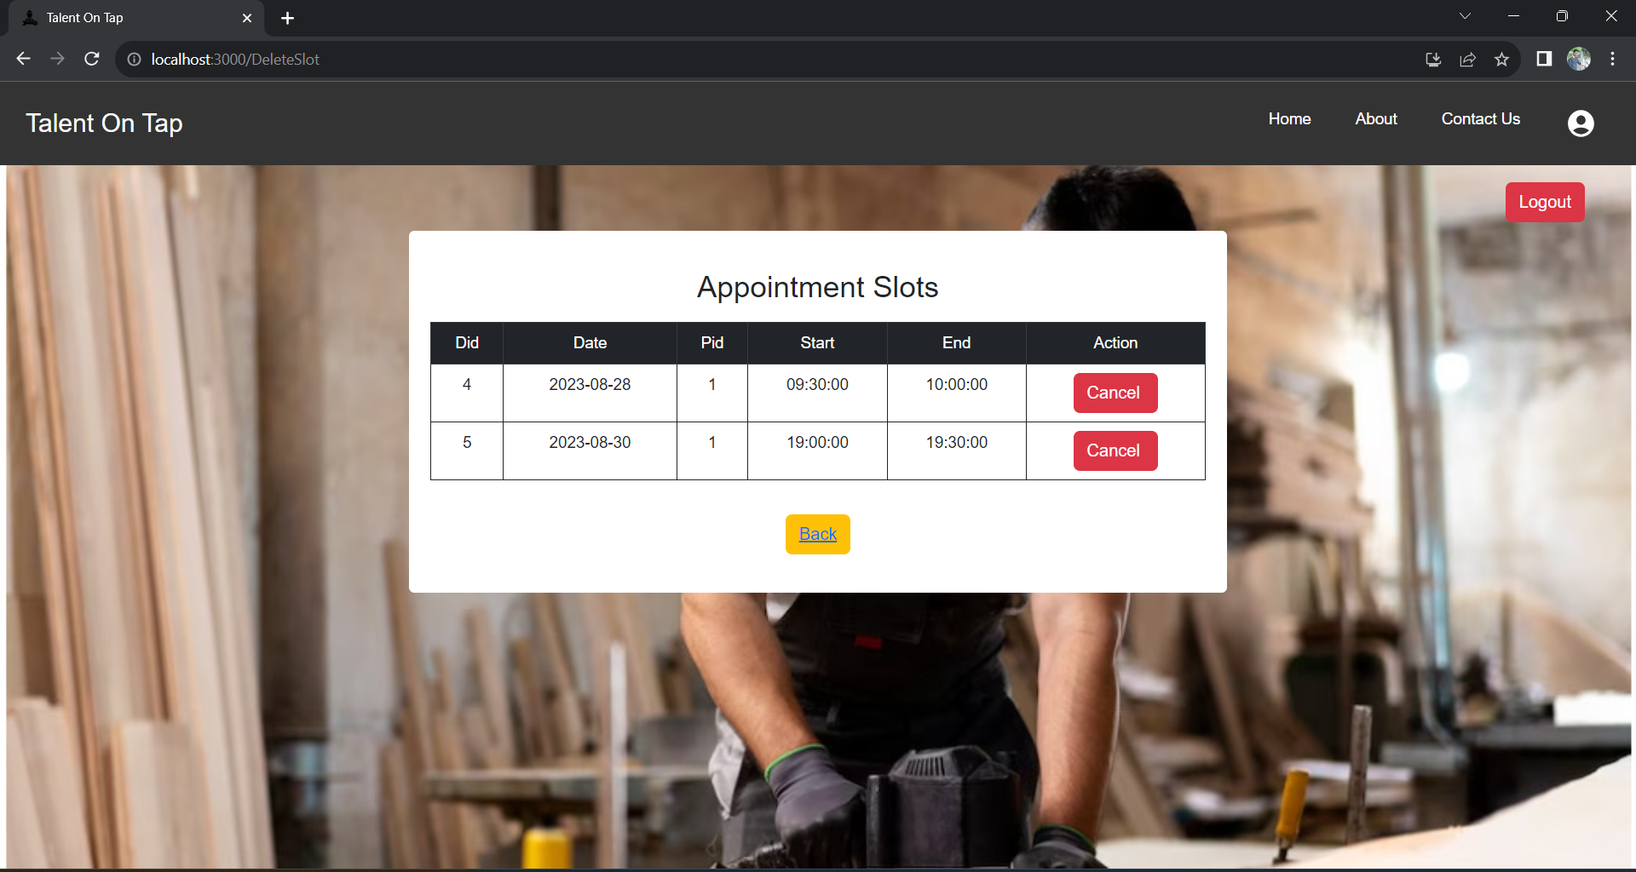

**Review and Rating :**

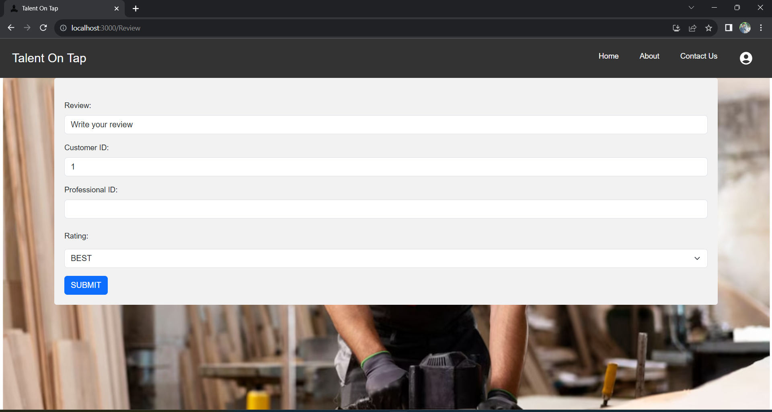

**FUTURE SCOPE**

Geographical Expansion:

One of the primary future scopes is to expand the application's reach to new geographical regions, catering to a broader audience and connecting users with local professionals offering a diverse range of services.

Additional Service Categories:

Introducing new service categories, such as home maintenance, pet care, and wellness services, can enhance the application's offerings and cater to a wider array of customer needs.

Advanced Communication Features:

Incorporating advanced communication tools like real-time chat, video consultations, and appointment reminders can further streamline interactions between customers and professionals.

AI-Powered Recommendations:

Implementing artificial intelligence to suggest personalized services based on user preferences, previous bookings, and browsing history can enhance service discovery.

# CONCLUSION

# In conclusion, the journey of developing the Talent on Tap on-demand home service application has been one of innovation and dedication. Through a rigorous process of analysis, design, and implementation, we have successfully crafted an application that defines how customers access and professionals deliver home services. The various features, user-centric design, and robust architecture converge to create an ecosystem that simplifies service booking, enhances communication, and elevates the overall user experience.

# The application's commitment to security and privacy ensures that users can engage with confidence, while the transparent feedback mechanism establishes accountability and trust within the service community. Furthermore, the administrative control tools empower platform moderators to uphold service quality and maintain the integrity of the system.

# The Talent on Tap application not only addresses the challenges faced by customers and professionals in the home service domain but also paves the way for future scalability and enhancements. This journey has been marked by lessons learned, challenges overcome, and a collective effort to create a lasting impact. As we move forward, we remain dedicated to refining and expanding the application, continuously striving to provide efficient and innovative solutions to the evolving landscape of on-demand home services.

**REFERENCES**

* + - 1. JavaScript Enlightenment, Cody Lindley-First Edition, based on JavaScript 1.5,

ECMA-262, Edition

* + - 1. Mc Graw Hill’s, Java: The complete reference 7thEdition, Herbert Scheldt
      2. Complete CSS Guide, Maxine Sherrin and John Allsopp-O'ReillyMedia;

September 2012

## ONLINE REFERENCE

1. [www.Google.com](http://www.google.com/)
2. [www.w3school.com](http://www.w3school.com/)
3. [www.javatpoint.com](http://www.javatpoint.com/)
4. [https://docs.spring.io/spring-framework/docs](https://docs.spring.io/spring-framework/docs/current/reference/html/)
5. https://getbootstrap.com/docs/4.0